To be completed electronically by the student and submitted with each piece of work. Please upload this completed cover sheet via Turnitin
Assignment Title: Code-Lab 1 (Utility App - Assessment 2)
Tutor: mohammed israr
Student Name: mohamed esam eltoum
Student Number: fbt250070
Date of Submission: 3-1-2026
Details of your submission
Online submission:
GitHub Repository Link:
https://github.com/Mohammed1Esam2Eltoum/my-fbt-vending-machine-task-2

YouTube Video Link:
https://youtu.be/7M3tDjTMxYg

In submitting this assignment, I am confirming that I have read and understood the regulations for assessment, and I am aware of the seriousness with which the University regards unfair practice.

Signed:
Date: 3-1-2026

Specification
- The buyer may input the name of the item they want
- Upon inputting the name of the time, they will be asked to pay
- If the amount inserted into the machine is equal to the item’s price or exceeds it, the process will be completed
- If the amount is less than the item’s price, the process will fail
System Flowchart
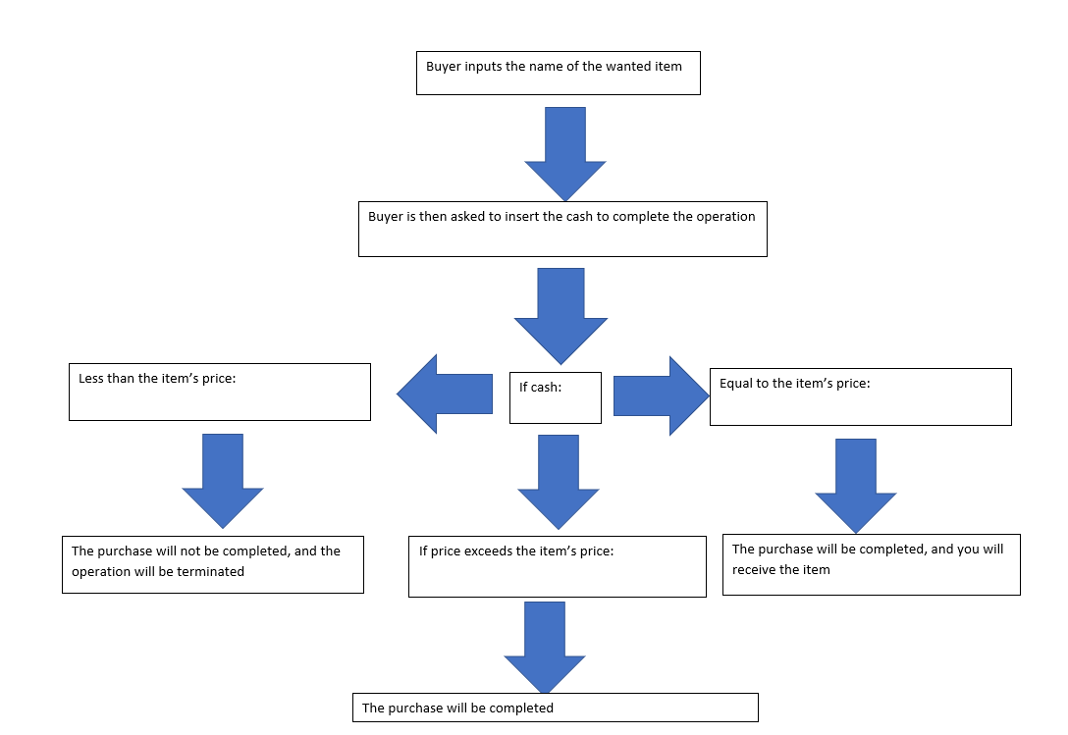

Technical Description & Walkthrough:

https://youtu.be/7M3tDjTMxYg

Critical Reflection:
- The aspect of this code I find the most compelling is how it can be used for virtually infinite number of times. The line is clear, concise and straight to the point, it’s easy for beginners to replicate, add and study from.
- What I believe could be improved upon is adding a command that lets you choose between paying with a card/phone or cash.
- The skills for making a code like this would be python and English language skills.

APPENDIX
http://localhost:8888/notebooks/vending%20machine.ipynb

